

Extreme Precision Radial Velocity (EPRV) Astronomy and the IVOA

Version 1.0
IVOA Note. 2025 May 25 2025

This version:
1.0
Latest version:
1.0
Editors:
Bruce Berriman (Caltech/IPAC) and Jennifer Burt (JPL)

Contributors:

Bruce Berriman (Caltech/IPAC)
Chad Bender (University of Arizona)
Jennifer Burt (JPL)
B. J. Fulton (Caltech/IPAC-NExScI)
EPRV Working Group

Revision Control
TBA

Abstract

Extreme Precision Radial Velocity (EPRV) refers to Doppler velocity measurements derived from high resolution, high signal-to-noise, stellar spectra that have single measurement statistical uncertainties of ≤30 cm s⁻¹. The EPRV measurement technique is generally acknowledged as the most promising ground-based method for discovering and measuring the masses of temperate, Earth-mass planets orbiting nearby, Sun-like stars which induce a Doppler reflex motion of only ~10 cm s⁻¹. While these “Earth-analog” planets remain beyond the detection capabilities of modern EPRV spectrographs to date, maximizing the knowledge gained from these instruments and optimizing their output is an essential step towards detecting Earth analogs.
An international working group is developing standardized formats for the spectral and time-series EPRV data products delivered by modern instruments. The group desires to make these data formats compatible with IVOA and FAIR standards in order to support wide discoverability and accessibility and to enable interoperability with related datasets. Community coordination and collaboration regarding data availability, data analysis techniques, statistical tools, and results from the dozen+ EPRV spectrographs now in operation will be required to advance the field toward its goal of detecting planets like the Earth.

Status of This Document
This is an IVOA Note expressing suggestions from and opinions of the authors. It is intended to share best practices, possible approaches, or other perspectives on interoperability with the Virtual Observatory. It should not be referenced or otherwise interpreted as a standard specification.
A list of current IVOA Recommendations and other technical documents can be found at http://www.ivoa.net/Documents/.

Contents

1 Introduction 3
2 EPRV Projects 4
3 EPRV data products 5
4 Use cases for distributed EPRV data. 6
5 Standards of interest 8
6 Summary 8
References 8

1 Introduction
The discovery and characterization of Earth-analogs, Earth-mass planets orbiting in the Habitable Zones of Sun-like stars, using Extreme Precision Radial Velocity (EPRV) spectrographs is extremely challenging. These planets produce an RV semi-amplitudes of only 10 cm s⁻¹, a factor of 3x below current Radial Velocity (RV) single measurement precision capabilities and 50x smaller than the RV variability seen in a “quiet” star like the Sun [1]. Despite these daunting challenges numerous space and ground-based astronomy agencies (e.g. NASA and ESO) have identified EPRV capabilities as key to detecting Earth analog planets and to supporting future space-based, high contrast direct imaging (HCDI) instruments that will image and record atmospheric spectra of such planets [2,3].
Over the last decade a new generation of RV instruments have come on line, each designed from the ground up to provide the exacting environment control and wavelength calibration necessary to achieve better than 30 cm s⁻¹ stability over timescales of months to years [4,5,6,7]. These instruments were developed by a variety of teams around the globe, and those teams have in turn implemented a variety of approaches in both their hardware and data reduction software designs. Comparisons of contemporaneous solar observations from multiple EPRV instruments show good agreement at the level expected given analytical errors [8], yet little has been done to investigate how differences in hardware and/or software impact the RVs obtained from each instrument. While this current generation of spectrographs’ hardware designs are now frozen, there is still much that can be learned and improved on the data reduction sides of these instruments if the EPRV community can easily access and compare the relevant data products.
Direct comparisons between modern EPRV instruments can be used both to improve the return from existing data and to inform design decisions for future instruments. With this motivation in mind, we have developed a community recommendation for a standardized EPRV data format that incorporates input from more than a dozen modern EPRV instrument teams and from the observatories and archives that host the data for these instruments. The resulting data format will also serve as an easily adoptable baseline for future EPRV spectrographs and allow instrument teams to save the time and effort required to design a bespoke format.
The EPRV Data Format team was convened in Fall of 2023 and we expect to produce the first draft of the EPRV Data Standard in Summer 2025, with a public roll out planned for the July 2025 EPRV 6 conference. After this roll out, a change control board established by the team will be in charge of receiving feedback from the community and deciding upon any major changes or updates to the data standard.

2 EPRV Projects

Typical exoplanets induce radial velocity changes of 100 m s⁻¹ down to 10 cm s⁻¹ on their host stars. RV instruments operate in the visible (400 - 900 nm) or near infrared (1-2μm) regimes and utilize CCD detectors with pixel scales of roughly 1 km s⁻¹ pixel⁻¹, so planet-induced Doppler shifts have typical scales of only 0.1 to 0.0001 pixels. Such shifts cannot be measured using a single absorption line, and must instead be determined via a “bulk” RV measurement that combines the signal of 100s or 1000s of lines within a stellar spectrum. RV instruments are therefore built around very high resolution (R ≡ λ/Δλ ≥ 80,000) échelle spectrographs that cross-disperse incoming light into dozens of diffraction orders. Key to this endeavor is the precise determination of a corresponding wavelength solution for each spectrum, in order to measure the absorption lines' central wavelengths to high fidelity.

Many modern RV spectrographs (see Table 1 and references therein) are placed inside stabilized enclosures that actively control the atmospheric pressure and temperature to micro-Torr and milli-Kelvin levels, respectively. This decouples the spectrograph from its surrounding environment thereby mitigating temperature and pressure variations that would otherwise deform the spectrograph optics and shift the spectrum and/or change the instrument's focus. These instruments are fiber-fed and include at least two fibers, one “science” fiber that is pointed at the science target and a second “calibration”' fiber that is pointed at a wavelength calibration source such as a HCL or a laser frequency comb (LFC). Once the stellar spectrum has been extracted and the corresponding wavelength solution has been determined, the spectrum is then cross-correlated against a binary mask of absorption line locations based on the spectral type of the observed star.
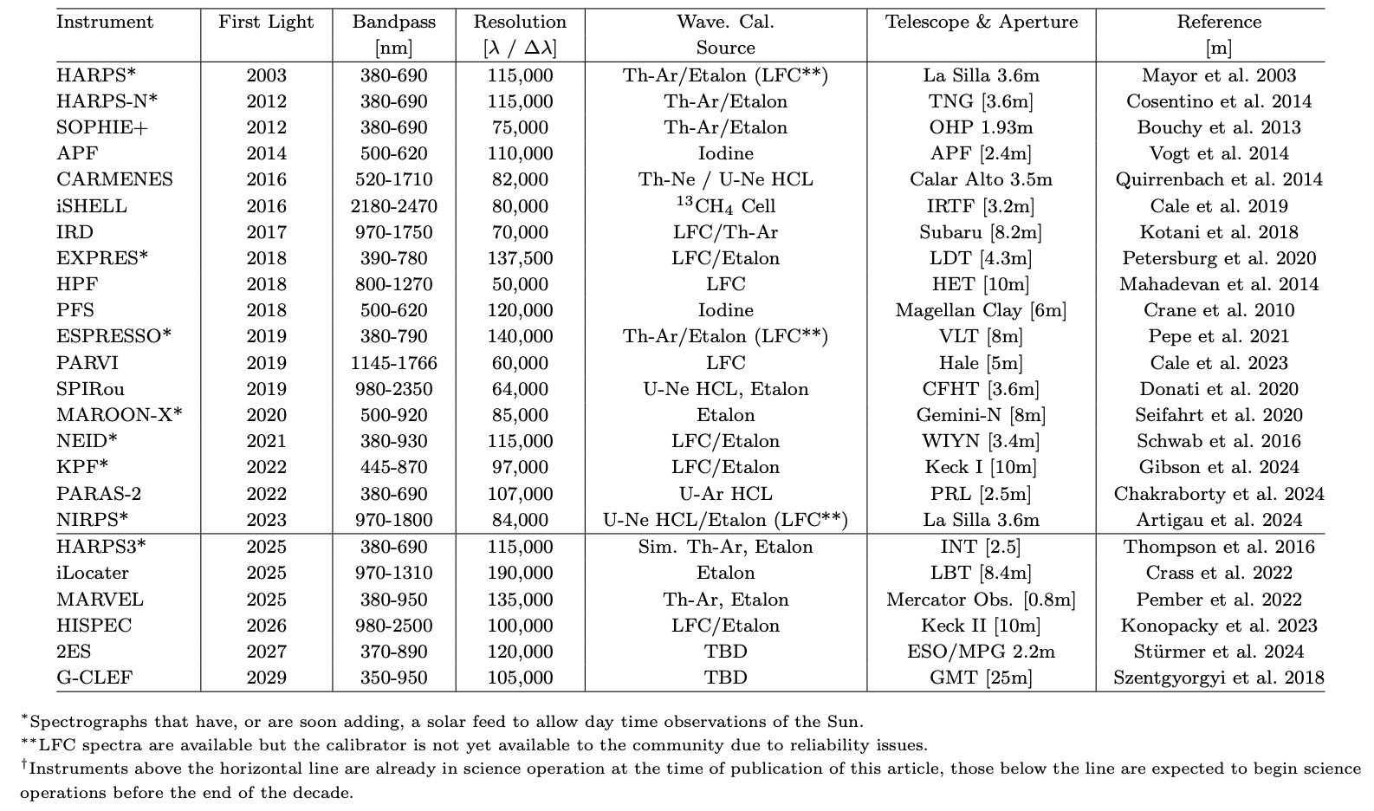
Table 1: Radial velocity spectrographs capable of delivering better than 1 m s⁻¹ single measurement precision in the visible bandpass and/or better than 3 m s⁻¹ in the near infrared.

3 EPRV data products
We have adopted a modified version of NASA’s L0, L1, etc data product levels, as outlined below. Given the individual nature of most EPRV instruments we do not develop a standard for the raw data (L0 and L1), but rather begin our standard definition at the extracted, order-by-order spectrum level (L2). Beginning with L2, each EPRV standard data product is a FITS file with a PRIMARY header designed by the team to capture essential information for the identification, interpretation, and processing of the observation. The PRIMARY Header and the L2 - L4 data products are described in more detail on our project’s ReadtheDocs page : https://eprv-data-standard.readthedocs.io/en/develop/

- Level 0 : The raw image produced by the spectrograph. Not included in the EPRV data standard.
- Level 1 : The assembled echellogram after the various amplifier readouts have been appropriately oriented and any overscan and bias corrections have been applied. Not included in the EPRV data standard.
- Level 2 FITS file: The order-by-order flux, wavelength, variance, and blaze arrays, which will be split into individual extensions. At Level 2 the only correction that has already been applied to the required wavelength solution is a drift correction. The information necessary to execute common EPRV corrections to the wavelength and flux extensions (e.g. blaze corrections and barycentric corrections) are provided in separate extensions but not yet applied. This data product is intended primarily for users who are interested in the improving EPRV data reduction and post processing techniques.

- Level 3 FITS file: A 1-D spectra that stitches together all extracted orders. The flux array will have been blaze corrected and the wavelength solution will have been both drift and barycentric corrected. The variance array will be calculated using the blaze-corrected flux. This data product is intended primarily for users who are interested in other types of science that can be accomplished with high resolution visible / NIR spectra. Potential examples include science related to exoplanet atmospheres or stellar astrophysics.
- Level 4 FITS file: Derived data products such as RV measurements, cross correlation functions (CCFs), CCF metrics (e.g., FWHM, BIS), and stellar activity indicators. Only the RV measurements are required, to support non-CCF RV reduction methods. This data product is intended primarily for users who are interested in applying different exoplanet detection techniques to EPRV data.

The standard allows users to adopt their preferred bit depth for most extensions, but both the wavelength extension and the Barycentric Julian Date (BJD) extension must be Float64 in order to ensure the precision necessary for sub-m s⁻¹ RV precision.

We do not require/suggest that existing EPRV instruments modify their native data formats to comply with the standard. Instead we have developed open-source, python-based, ‘translator’ tools for a number of EPRV instruments that take the native data format as an input and produce an EPRV standard compliant FITS file as an output. This allows each instrument team to capture the nuances of their instrument and to update their individual translator if changes are made either in their own data reduction pipeline or in the EPRV standard (as overseen by our change review control board).

The EPRV data standard has been designed with VO / IVOA compliance in mind. If, however, changes are required to achieve full compliance that prove problematic for the EPRV standard’s utility in the community then it would be straightforward to develop an additional translator layer to move from the community EPRV standard to a fully IVOA compliant EPRV standard.

4 Use cases for distributed EPRV data.
Thorough characterization of exoplanets requires a comprehensive analysis not just of the planet itself but also its host star and the system in which they both exist (Figure 1).
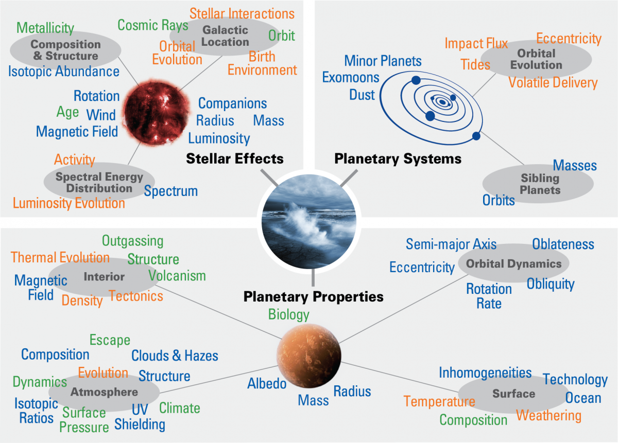
Figure 1: Visualization of the many factors that influence the formation, evolution, and modern day characteristics of a planet (credit: Meadows & Barnes). Comprehensive characterization of a planet requires the collection and analysis of data across many wavelengths, formats, and timescales.

While this note is focused on the standardization of a specific type of data, namely EPRV spectra, modern exoplanet discovery and/or characterization papers include numerous types of data (e.g., photometric time series, RV time series, broadband photometry, high resolution imaging, etc) all of which contribute to our understanding of the planetary system []. Identifying what data sets already exist for a given star and its planet(s) often requires intensive literature searches and querying numerous catalogs via interfaces like Simbad or Vizier. Adoption of IVOA standards within exoplanet-related data sets would allow for more efficient and effective identification of existing data, ensuring that planet characterization efforts leverage as much information about the system as possible.
As the EPRV standard is adopted and applied to data hosted on various public archives, access through IVOA standards will allow the community to:
1. Discover and access EPRV data sets for a specified star or set of targets through a common interface. Recent works such as
2. Discover and access additional data related to the host star, e.g. additional spectra or photometric time series, that can be used to quantify the star’s mass, radius, rotation period, chemical composition, and other physical characteristics that impact our interpretation of both stellar variability and planetary signals.
3. Discover and access EPRV data of the sun generated by the growing population of small, solar telescopes that feed EPRV spectrographs during the daytime hours.

5 Standards of interest
The obvious IVOA standards are the IVOA spectral data model (SDM):

https://ivoa.net/documents/SpectrumDM/20231215/index.html

and the SSA specification:

https://ivoa.net/documents/SSA/20120210/index.html

Neither document addresses how to manage echelle data in detail. The current FITS standard does not handle the changes in wavelength dispersion required to accurately capture the wavelength solution for an echelle spectrograph, and an IVOA standard must address this issue.

6 Summary
The high resolution spectra produced by EPRV spectrographs can be utilized for a variety of science cases (e.g. stellar compositions, age dating, and magnetic variability studies) in addition to their primary use of determining the masses and orbital characteristics of exoplanets. The intent of the EPRV data standard project is to increase the accessibility of modern RV spectra by adopting a set of standardized FITS file formats so that users do not need to learn the intricacies of multiple instrument pipelines and their data products.

Ensuring that our new EPRV data format is compliant with IVOA standards will further this goal by making EPRV data hosted in public archives more discoverable and accessible both across different EPRV teams and across different exoplanetary and stellar science communities.

References
[1] Collier Cameron et al., 2021, “Separating planetary reflex Doppler shifts from stellar
variability in the wavelength domain” , Monthly Notices of the Royal Astronomical Society,
Volume 505, Issue 2, pp.1699-1717
[2] National Academies of Science, “Exoplanet Science Strategy Report”, 2018,
https://www.nationalacademies.org/our-work/exoplanet-science-strategy
[3] Crass et al., 2021, “Extreme Precision Radial Velocity Working Group Final Report”, arXiv:2107.14291
[4] Schwab et al., 2016, “Design of NEID, an extreme precision Doppler spectrograph for WIYN”, Proceedings of the SPIE, Volume 9908, id. 99087H
[5] Brewer et al., 2020, “EXPRES. I. HD 3651 as an Ideal RV Benchmark” , The Astronomical Journal, Volume 160, Issue 2
[6] Pepe et al., 2021, “ESPRESSO at VLT - On-sky performance and first results” , Astronomy &
Astrophysics, Volume 645, id.A96
[7] Seifahrt et al., 2022, “MAROON-X: the first two years of EPRVs from Gemini North” ,
Proceedings of the SPIE, Volume 12184, id. 121841G
[8] Zhao et al., 2023, “The Extreme Stellar-signals Project. III. Combining Solar Data from HARPS, HARPS-N, EXPRES, and NEID”, The Astronomical Journal, Volume 166, Issue 4, id.173

